http://antrodelnerd.blogspot.com/2011/01/sigil-creare-e-modificare-epub.html
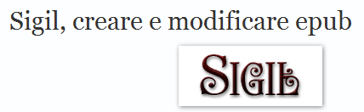
http://code.google.com/p/sigil/

