Ebook store

<http://www.ibs.it/ebook/100/100ebk.asp>



<http://www.net-ebook.it/?utm_source=pianetaebook&utm_medium=link&utm_campaign=Pianetaebook>

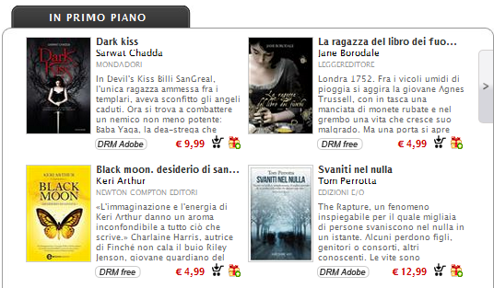

<http://www.bookrepublic.it/>

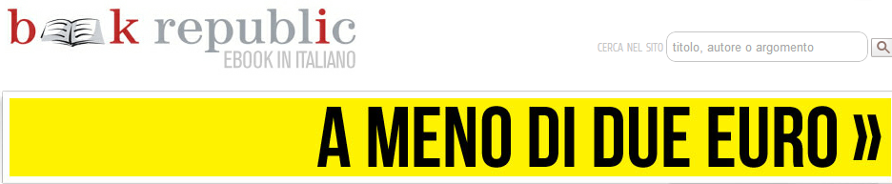

<http://www.ultimabooks.it/bestsellers>



<http://www.lafeltrinelli.it/fcom/it/home/pages/classifiche/top-eBooksita.html>



<http://libreriarizzoli.corriere.it/ebook>

