Social list

http://sociallist.org/code-widget.php?lang=en&button_dx=160&button_dy=24&cols=3&rows=5
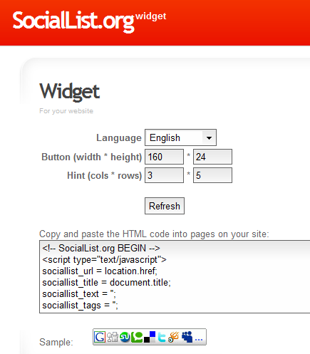

<!-- SocialList.org BEGIN -->
<script type="text/javascript">
sociallist_url = location.href;
sociallist_title = document.title;
sociallist_text = '';
sociallist_tags = '';
</script><script type="text/javascript" src="http://sociallist.org/widget.js?type=1&cols=3&rows=5&button_dx=160&button_dy=24&lang=en"></script>
<noscript>
<a href="http://sociallist.org/submit.php?type=1&lang=en&url=refpage&title=refpage&tag=refpage&text=refpage" target="_blank" title="Bookmark this Website"><img src="http://sociallist.org/buttons/en160x24.gif" border="0" width="160" height="24" alt="Bookmark" /></a>
</noscript>
<!-- SocialList.org END -->

