Risorse
http://www.caricaturesoft.com/online-tools/cartoons/ | 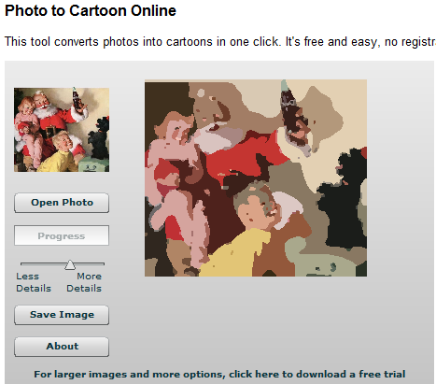 | Software on line free per trasformare le immagini in caricature o cartoon

